WEBSITE NAME HERE

& WIREFRAME

A Final Output Presented to the School of Computing

Holy Angel University



In Partial Fulfillment

of the Requirements for the Degree

School of Computing

Submitted to:

Mr. AGASSI ROJO

6INTROWEB Instructor

Submitted by:

CANLAS, CARL MICHAEL P.  
CYB - 201

November 2023

**Website Plan**

|  |  |
| --- | --- |
| Website Name | Trip Mo, Trip Ko |
| Purpose of the Website | At Trip Mo, Trip Ko, my purpose is to inspire and facilitate unforgettable journeys throughout the beautiful province of Pampanga. I am committed to curating exceptional travel experiences that create cherished memories, promote sustainable tourism, and showcase the diverse beauty of this region while making travel in Pampanga easy and fast.  With a deep passion for the province's rich heritage, pristine nature, and warm hospitality, we strive to make every journey an exploration of Pampanga, leaving a positive impact on both our travelers and the local communities we engage with. |
| Target Audience | I'm committed to creating amazing travel experiences for travelers who appreciate quality and adventure in Pampanga. |
| Graphics |  |
| Color | #eb742f  #F8F6F3  #30343A  #2ecc71  #e74c3c |
| Accessibility | To make my website accessible to people with disabilities, it's crucial to follow best practices for web accessibility. This includes features like providing alt text for images, implementing keyboard navigation, and ensuring compatibility with screen readers. My website should also offer options for adjustable text sizes and high-contrast themes to accommodate users with visual impairments, ultimately making the content accessible to a broader audience. |
| Project Timeline | Less than a month |

**Site Map/Diagram**

**Figma Wireframe** (for all pages & viewports)

**Desktop:**

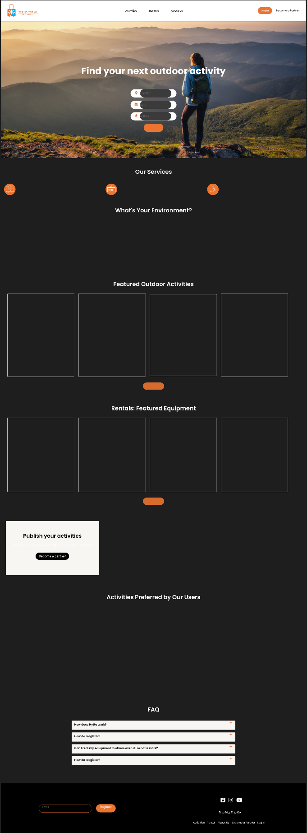

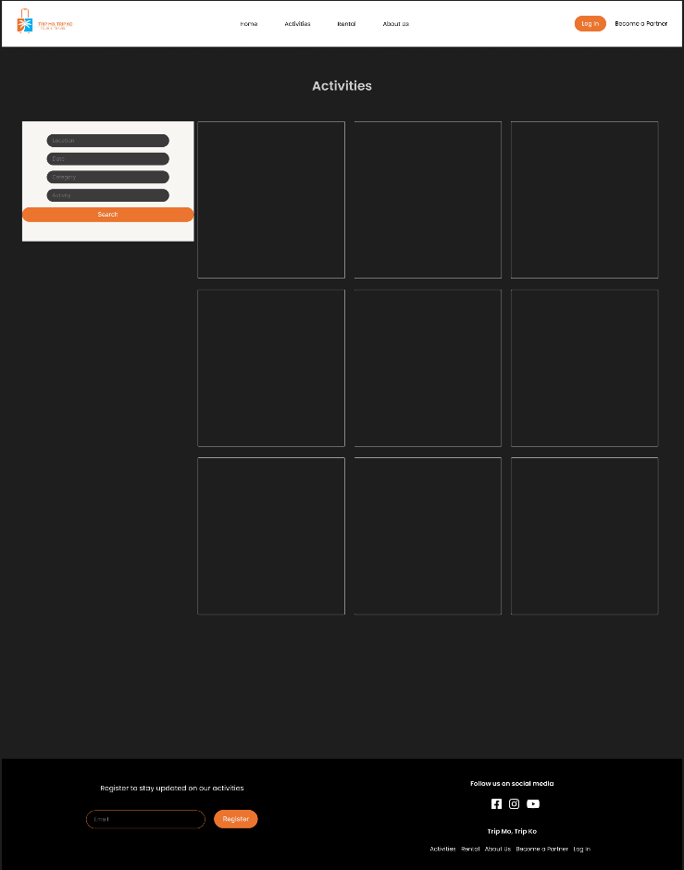

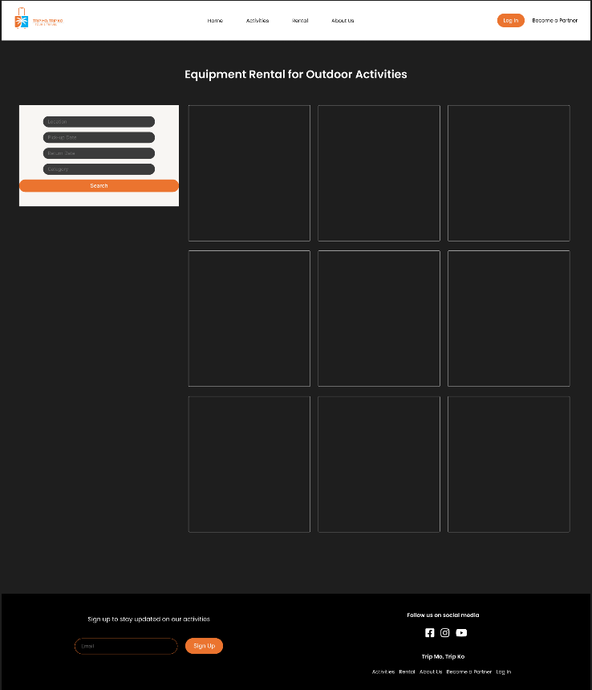

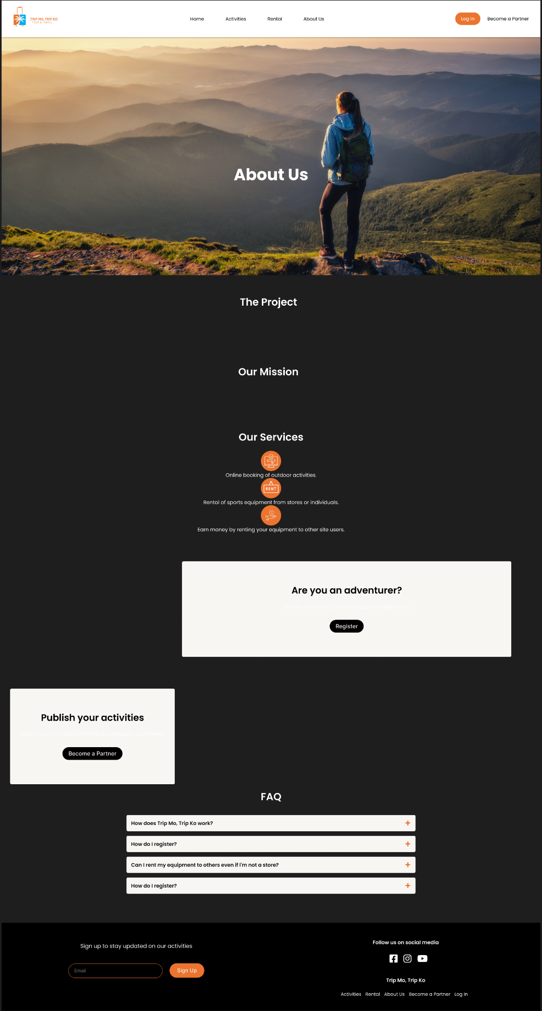

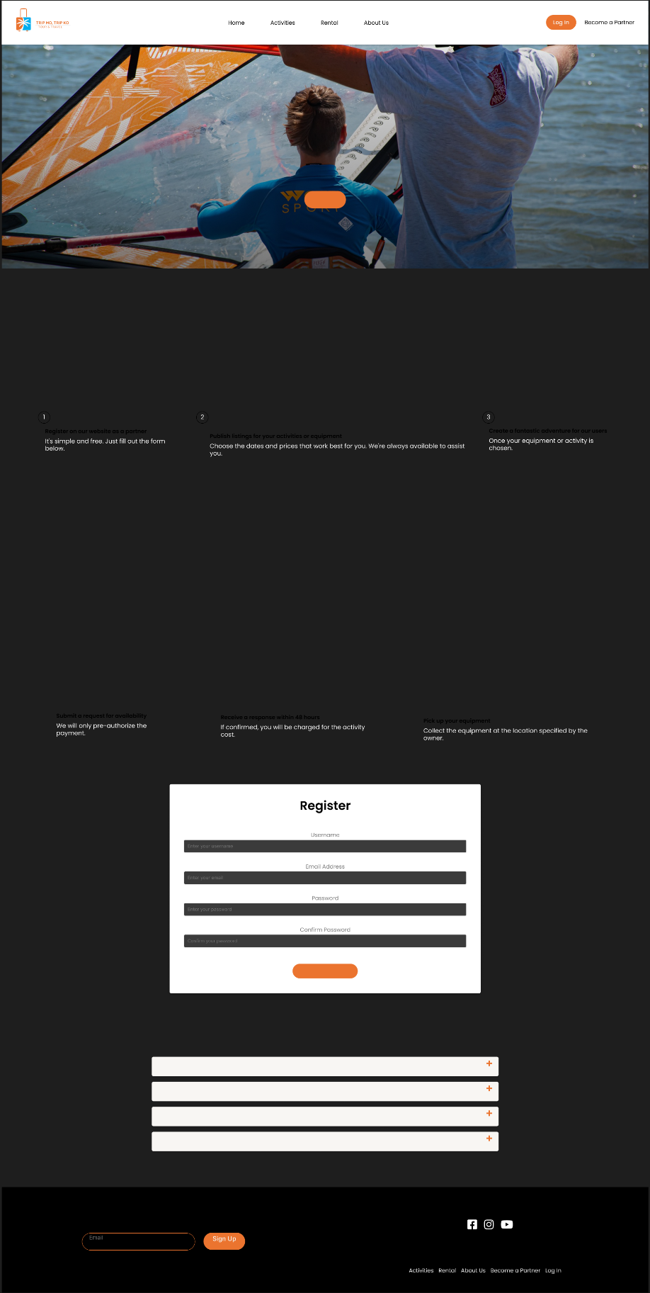

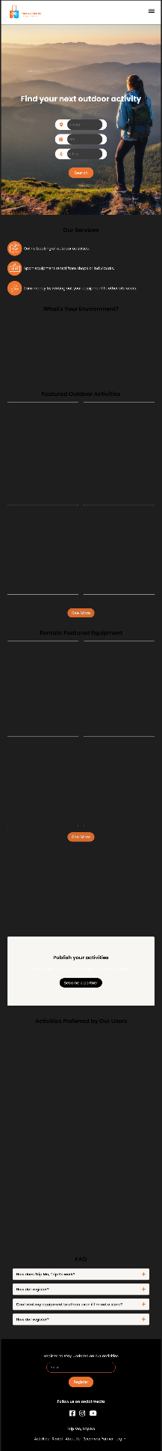**Tablet:**

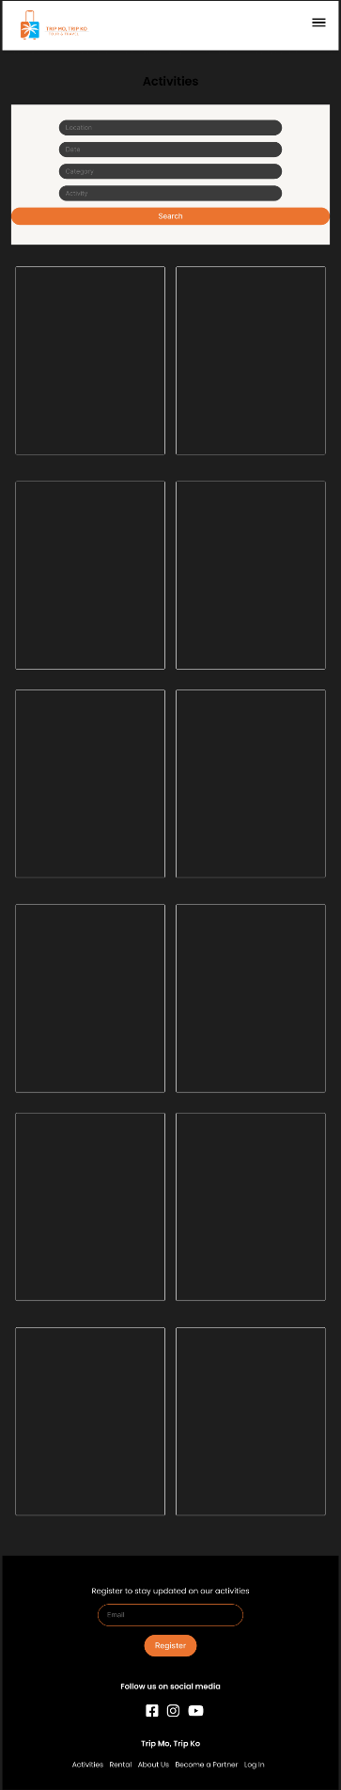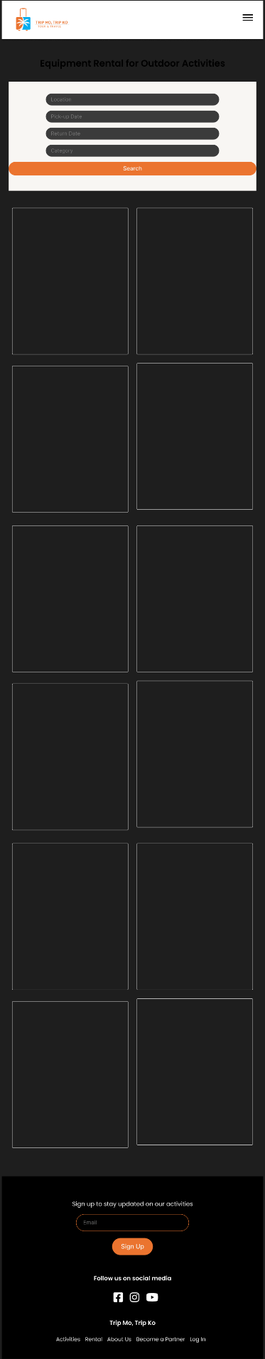

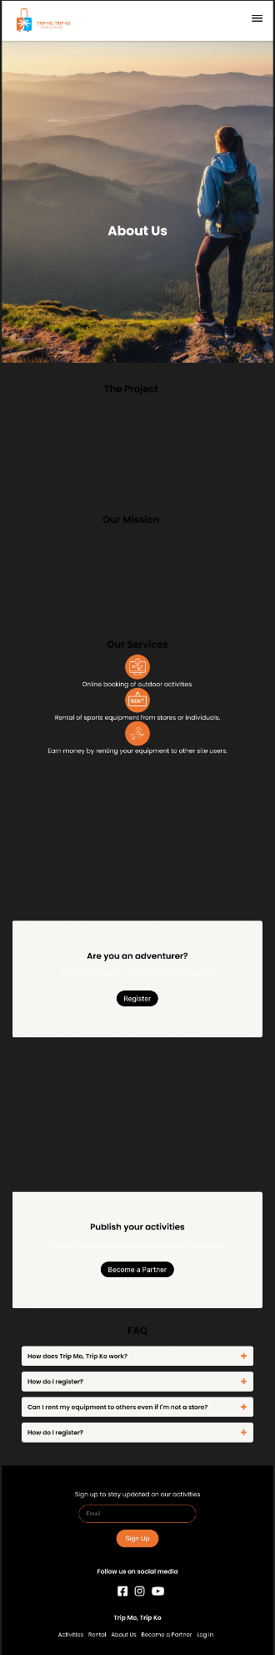

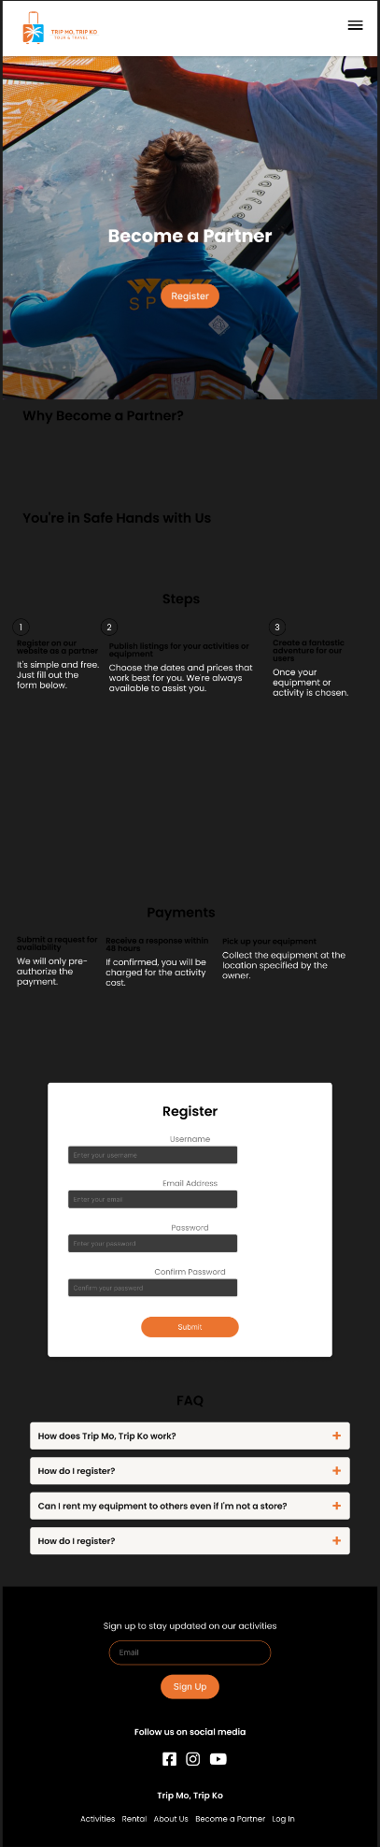

**Mobile:**



**Rubrics for Grading the Website**

|  |  |  |  |  |
| --- | --- | --- | --- | --- |
|  | **4** | **3** | **2** | **1** |
| **Content & Accuracy,**  **Spelling & Grammar (20%)** | The site has a well- stated clear purpose and theme that is carried out throughout the site.  All information provided by the student on the Web site is accurate and all the requirements of the assignment have been met.  There are no errors in spelling, punctuation, or grammar in the final draft of the Web site. | The site has a clearly stated purpose and theme but may have one or two elements that do not seem to be related to it.  Most of the information provided by the student on the Web site were accurate and most of the all requirements of the assignment have been met.  There are 1-3 errors in spelling, punctuation, or grammar in the final draft of the Web site. | The purpose and theme of the site is somewhat muddy or vague.  Some of the information provided by the student on the Web site were accurate and some requirements of the assignment have been met.  There are 4-5 errors in spelling, punctuation, or grammar in the final draft of the Web site. | The site lacks a purpose and theme.  All the information provided were not accurate and requirements of the assignment were not met.  There are more than 5 errors in spelling, punctuation, or grammar in the final draft of the Web site. |
| **Layout (15%)** | The Web site has an exceptionally attractive and usable layout. It is easy to locate all important elements. White space, graphic elements and/or alignment are used effectively to organize material. | The Web pages have an attractive and usable layout. It is easy to locate all important elements. | The Web pages have a usable layout but may appear busy or boring. It is easy to locate most of the important elements. | The Web pages are cluttered looking or confusing. It is often difficult to locate important elements. |
| **Theme & Consistency (Color Choices, Background)**  **(10%)** | • Website uses a consistent color scheme throughout the website.  • Less than three fonts are used and they consistently highlight titles and have readable content.  • Pages all seem related. | • Website has a color scheme.  • Less than three fonts are used. | • Website uses a color scheme, but not all pages are the same.  • Less than three fonts are used within the website. | • Website has randomly chosen elements throughout.  • More than three fonts are used within the website. |
| **Creativity & Design (Graphics) (15%)** | The web site has an exceptionally attractive and usable design. It is easy to locate all important elements. White space, graphic elements and/or alignment are used effectively to organize material. | The web site has an attractive and usable design. It is easy to locate most of the important elements. White space and/or alignment are used to organize material. | The web site has an attractive and usable design. It is easy to locate some of the important elements. White space and/or alignment are used to organize material | The web site is poor in design. It is hard to locate important elements. The material was not organized. |
| **Navigation (10%)** | Links are clearly labeled, consistently placed, and allow the reader to easily move from page to page. | • Links are labeled and allow the reader to easily move from page to page. | Links allow the reader to move from page to page, but some links seem to be missing. | Links seem to be missing and don’t allow the ready to easily navigate. |
| **Coding Style (HTML, CSS, JS)**  **(15%)** | The coding style used was 100% readable. It follows the standard in using HTML 5 Semantics and CSS 3 Layout tags. All tags utilized were efficient, usable, and recommended for future references. Established JS. | The coding style used was 70% readable. It follows the standard in using HTML 5 Semantics and CSS 3 Layout tags. Most tags utilized were efficient, usable, and recommended for future references. Some JS. | The coding style used was 50% readable. It follows the standard in using HTML 5 Semantics and CSS 3 Layout tags. Some tags utilized were efficient, usable, and recommended for future references. Some JS. | The coding style used was not readable. It does not follow the standard in using HTML 5 Semantics and CSS 3 Layout tags. Tags utilized were not efficient, usable and cannot be recommended for future references. 0 JS. |
| **Responsiveness (15%)** | Responsive in all viewports with no errors | Responsive with deceivable errors | Responsive with many errors | Not responsive. |